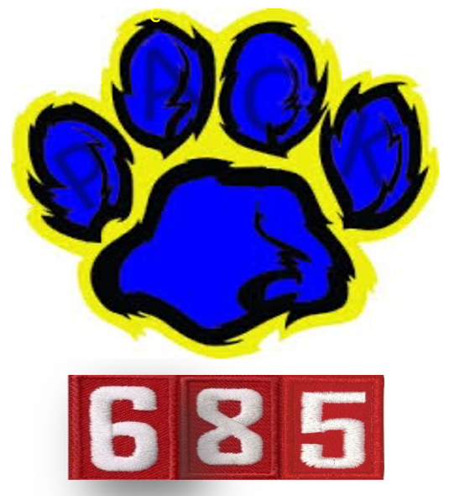
MAY 2024
Pack Email

Congratulations to Pack 685 for representing at the District Pinewood Derby in April. The Spring campout was so much fun at Rappahanock Campgrounds! Thanks Wolf leaders for planning all the wonderful stations - knot tying, fitness fun, wilderness survival, and fishing!

Always check out our website – www.pack 685.org

This email will include information for:
- Pack Meetings
- Committee Meetings
- Upcoming Pack Fun
  - Pack Picnic
  - Memorial Day Tomb Ceremony - volunteers needed!
- Adult Volunteers Needed! New programming year!
- Summer Camps (Day Camp and Camp Ross at Goshen)
- Scout Day @ Nats Park!
- Pack Website Photos
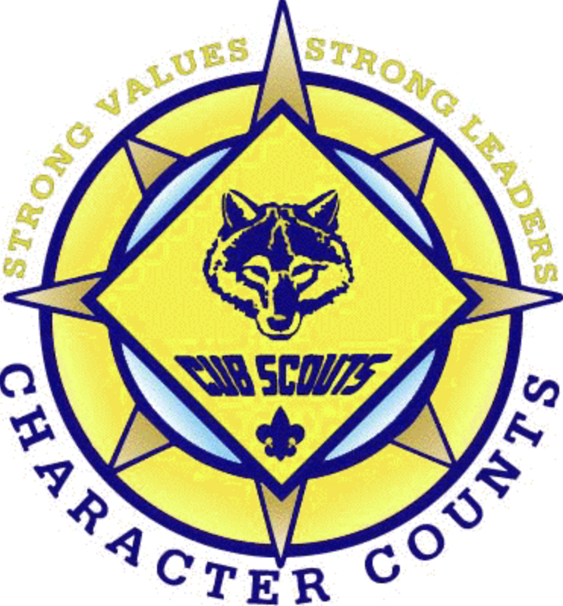

1.MEETINGS
Pack Meeting (4th Thursday of every month @ 7:00pm – OHES Cafeteria)
Who: Pack 685 Scouts and Families
What: Monthly Pack meeting.
When/Where: 4/25/2024 @ 7:00pm (Webelos, Bear & Wolf Rank Advancement)
When/Where: 5/30/2024 @ 7:00pm (Tiger and Lion Rank Advancement)
POC: Cubmaster EJ <ejramos04@gmail.com>
**Webelos Advancement delayed. Fourth Graders have a field trip to Richmond returning late ~ 6:30pm (historically later

2. COMMITTEE MEETINGS (Sunday before Pack Meeting)
Who: Any Parent interested in volunteering and learning more about Scout programming.
What: Interested in the scout program planning? Interested in volunteering but do not know how? Come and join us at a Pack Committee Meeting and meet all our leaders! Consider helping on the administrative side (no scout interaction).
When/Where: 5/5/2024 @ 6:00pm - special budgeting and program planning meeting
When/Where: 5/26/2024 @ 6:00pm - TBD
POC: Sara Root <sara.root97@gmail.com>

3. UPCOMING PACK FUN:
Pack Picnic
What: We will enjoy our last Pack activity before the summer and end of school with Kona Ice! We will be distributing tickets – one for each Cub – to enjoy a free Kona Ice. Other attendees are welcome to buy Kona Ice to enjoy!
We will have tables with the following: 2024 Cub Scout Program updates, Crafts, Appetizers/Snacks. And of course, the playground will be available for kids to run around and play! Bring a friend to check out Cub Scouts! Please help. Sign-up genius link: https://www.signupgenius.com/go/5080445A4AA23A46-48828272-pack
When: May 18, 2024 @ 3:00pm (OHES Parking Lot)
Email with details to follow.
POC: Kiran <kiran.talvadkar@gmail.com>

4. Memorial Day Tomb Ceremony
What: We need Scouts to represent Pack 685! This is an opportunity for your Scout to participate in the annual Memorial Day Tomb Ceremony event in Old Town, Alexandria for the 1st Virginia Regiment. Please complete the interest form before 5/20/2024.
*Additional details will be sent via email to interested participants.
When: Monday, May 27, 2024 (Arrive @ 9:00am)
Where: Old Presbyterian Meeting House (323 S Fairfax St, Alexandria, VA 22314)
Attire: Full Class A uniform (uniform top, neckerchief, slide, hat)
Email with details to follow.
POC: Wolf Den 9 Shawn <shawn.k.singh@gmail.com>

Summertime Fun Activities!
June
What: Fun in the Sun Regatta!
When: Come out and play some games!
Email with details to follow.

July
What: Fourth of July Car Parade
When: Thursday, July 4th (OHES Parking Lot)
Email with details to follow.

What: Cubs Scouts & STEM
When: TBD
Email with details to follow.
POC: Shawn <shawn.k.singh@gmail.com>

August
What: Back to School Bike Ride to Baskin-Robbins
When: Saturday, August 17th
Email with details to follow.

4.ADULT VOLUNTEER OPPORTUNITIES
Who: All parents
What: Volunteer for various positions to assist our Leaders deliver our Scouting Program.
Why: We need your help to plan and organize various activities/events, which will free up our Den Leaders to focus on Den Meetings and delivering the scouting program to your Scout. Consider helping the Pack Committee plan and deliver fun and meaningful programs to our Scouts.
- 2024 Summertime Fun Coordinator(s): June, July, August
- Recruitment Committee member (Start Summer 2024)
- Pack Committee Chair (Jan 2025) - train with Sara Root
- Parents with STEM backgrounds
POC: Jenn Schneider <jennifer.schneider@mail.com>

Thank you to our new volunteers:
- WKCA Spring Clean-Up Coordinator (April 2024) - Adam Jones (Bear/Den 3)
- Day Camp Coordinator (Start Feb 2024) - Lindsey Emami (Parent Volunteer))
- Assistant Cubmaster (Starting now) - Shawn Singh (Wolf/Den 9)
- Popcorn Kernel (Starting now) - Kelly Weaver (Wolf/Den 6)

5.SCOUT SUMMER CAMPS
NCAC Day Camp
Who: Rising Tigers to AOLs (rising 1st and 5th graders)
When: Summer Day Camp 2024 – June 24-28
Where: Occoquan Regional Park
Additional Information:
- Adult Volunteers: ALL Adults are FREE! Volunteers needed to maintain 1:5 (adult to scout ratio). Youth Protection Training (YPT) mandatory for all Adult volunteers at camp.
  - Rising Tigers Scouts must be accompanied by an Adult Partner everyday.
- Required Forms: BSA Medical Forms (A, B1, and B2) for Youth and Adults
- This is a combined Patriot and Old Dominion DIstrict day camp. Space is limited!!
- Registration is completed as a unit = Pack 685. If you are interested or have questions, contact the Day Camp Coordinator, Lindsey.
How: Email POC: Lindsey Emami <lindseylars@gmail.com>

Webelos Camp Ross @ Goshen Scout Reservation
Who: Current BEAR and WEBELOS I Scouts
What: Resident summer camp for one week at Goshen Scout Reservation.
When/Where: Summer Camp 2024 – June 23-29 (Sunday through Saturday AM)
Why: Camp Ross is a resident Webelos summer camp where scouts enjoy various scout programming including aquatics with a 23’ trampoline, nature area, handicraft area, archery range, BB range, and direct hiking trails. Camp Ross is great fun for Webelos and their leaders and the staff helps to provide an added level of comfort as these young cubs prepare to bridge into Scouts.
Required Forms: BSA Medical Forms (A, B1, B2, and C) for Youth and Adults
Watch video on Camp Ross - https://www.youtube.com/watch?v=CfRoy_-6VcM
How: POC: Sarah O’Rourke <saraheorourke@gmail.com>

6.NATIONALS SCOUT DAY
Who: Pack 685 Scouts and Families
What: Join fellow Scouts at Nationals Park for Scout Day! The Nats take on the Milwaukee Brewers! This should be a great event just as in years past! Every individual who purchases a Scout Day ticket will receive a limited-edition Nationals Scout Day patch, and $5 from each ticket will be donated to NCAC! More details will come closer to the game day, including the specific gate to enter!
When: Sunday, August 4, 2024 @ 1:35pm
Where: Nationals Park - 1500 S Capitol St SE, Washington, DC 20003
How: If you are interested - please complete the following interest form by 3/31/2024
https://forms.gle/hixUoUptnsow1com8
Ticket Details: Tickets prices will vary $38/ticket (no additional taxes & fees).
Tickets will likely be reserved and purchased in the RF Reserved depending on availability. I am coordinating with an account executive for ticket sales now.
Having the MLB Ballpark APP is required to digitally transfer the tickets and will be done once tickets are purchased/paid.
POC: Jenn Schneider <Jennifer.schneider@mail.com>

WEBSITE PHOTOS
Parents - If you DO NOT authorize the use of any photos, taken of yourself and/or my child, during Den or Pack Meetings to be utilized for Cub Scouts Pack 685 promotional materials/website usage as well as local newspaper usage, please let us know.
Send a message to Jenn Schneider <jennifer.schneider@mail.com>
